**[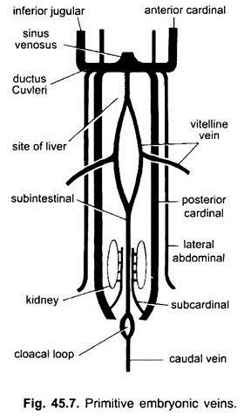](http://www.notesonzoology.com/wp-content/uploads/2017/07/clip_image014-28.jpg)**